**EXPERIENTIAL ENGINEERING**

**EDUCATION(ExEED) –FABRICATION MODEL DEVELOPMENT(ACSC14)**

**REPORT**

**ON**

### **TECH EVENT PLANNER AND MANAGER**

**AUTOMATIC STREET LIGHTS**

A Report submitted

**By**

P.KALYANI ROLLNO-23955A0408

**Ashraf Ahmed , Roll Number: 22951A6618 Hemanth Chowdary, Roll Number: 22951A6640**

H.MANJU BHASHINI ROLLNO-23955A0412

CH.PAVANI ROLLNO- 22951A04B8



**ECE (ELECTRONICS AND COMMUNICATION ENGINEERING)**

**INSTITUTE OF AERONAUTICAL ENGINEERING**

**(Autonomous)**

**Dundigal, Hyderabad–500 043, Telangana**

**AUGUST, 2024**



# ExEED – PROTOTYPE / DESIGN BUILDING

* **Problem Research (Background for getting the idea, Customer Pain Points, motivation for solving the problem)**

# Background for getting the idea:

Street lights have always been an unexchangeable part of our society. From the era of early Romans till now, the public lighting system is used in full force.

The street lights act as a source of light during the night to facilitate night vision, improve security, prevent accidents. These lights were operated manually which sometimes results in mis operations. And a huge amount of energy is wasted on these lights because of these mistakes. Smart street lights provide a solution to this worldwide problem. These lights are not only energy but also cost-effective. The system of smart street lights can be installed on existing infrastructure. They help us in saving energy in this era of energy crisis. And also make the lights automatic with less to no human intervention. LDRs (Light Dependent Resistors) act as a trigger to switching the lights ON and OFF. The lights turn on automatically as soon as the sun sets and turns off when the sun rises, thus preventing any mistake. Cameras are installed to keep an eye on the surroundings in case of accidents or any crime occurring. The installing of this system is complex and costly, however, it is of great help when installed and also cost-effective in the long run.

**Customer Pain Points:**

Night travel has always been troublesome and considered unsafe because of the lingering darkness. To get rid of this issue, the idea of public lightning was proposed by ancient Romans. A civilized and planned system was first used in the 16th century. Since then street lights have undergone many changes and updates to become what it is today. To overcome these shortcomings the idea of smart street lights was proposed. These lights are equipped with sensors, microcontrollers, etc. which makes this system smart. LDRs (Light Dependent Resistors) are the trigger to turn ON and OFF the smart street lights at Twilight. IR (Infrared) sensors sense the presence of vehicles and humans and switch ON

and OFF the street lights in the dead of the night. LEDs are used in this.

The idea for the tech event planning and management website emerged from recognizing a gap in the market for a comprehensive platform tailored specifically for organizing and participating in tech-related events. This realization stemmed from personal experiences and observations within the tech community, where finding and managing tech events often proved challenging and fragmented.

As an enthusiast in the tech field, I frequently encountered difficulties in discovering relevant

events, registering for them, and staying updated on event details. Similarly, event organizers struggled to effectively promote their events, manage registrations, and engage with participants

streamlined manner. Existing solutions lacked the specificity and user-friendliness needed to address the unique dynamics of tech events. Furthermore, conversations with fellow tech enthusiasts, organizers, and industry professionals revealed a shared desire for a centralized platform that could simplify the entire event management process, from planning and promotion

to registration and execution. Recognizing this opportunity, the idea crystallized to create a dedicated online hub that caters exclusively to the diverse needs of the tech event ecosystem.

## Customer Pain Points:

One significant pain point for customers in the tech event planning and management domain the fragmentation of event information across various platforms and sources. Tech enthusiasts often find it challenging to discover relevant events due to the lack of a centralized hub where they can easily browse and access comprehensive event listings. This fragmentation leads to inefficiencies and frustration as individuals must navigate multiple websites, social media platforms, and newsletters to stay informed about upcoming events.

Furthermore, once potential participants identify events of interest, they often encounter difficulties in the registration process. Different events may require registration through separate platforms or websites, each with its own set of requirements and procedures. This disjointed registration experience can be time-consuming and confusing, discouraging potential attendees from completing the registration process.

Moreover, inadequate event information exacerbates these pain points. Participants

may struggle to find detailed information about event agendas, speakers, topics, and logistics,

making it challenging to assess the relevance and value of attending a particular event.

Without sufficient information, individuals may hesitate to commit to attending, leading to missed opportunities for event organizers and decreased engagement within the tech community.



# The problem statement and its relevance to today's market / society / industry need:

**Problem Statement:**

The problem statement for the tech event planning and management industry revolves around the fragmentation and inefficiencies inherent in the current landscape. Despite the growing popularity tech events such as hackathons, tech talks, and marathons, participants and organizers alike face significant challenges in navigating the myriad of platforms and processes involves.

Automatic Street Light Control System is a simple yet powerful concept, which uses transistor as a switch. By using this system manual works are 100% removed. It automatically switches ON lights when the sunlight goes below the visible region of our eyes. This is done by a sensor called Light Dependent Resistor (LDR) which senses the light actually like our eyes. It automatically switches OFF lights whenever the sunlight comes, visible to our eyes. By using this system energy consumption is also reduced because nowadays the manually operated street lights are not switched off even the sunlight comes and also switched on earlier before sunset. In this project, no need of manual operation like ON time and OFF time setting. This project clearly demonstrates the working of transistor in saturation region and cutoff region. The working of relay is also known.

These traditional lights also have their pros and cons. These lights are switched ON and OFF manually. Hence sometimes mistakes happen. Like light remains ON even during the day. And by mistake sometimes lights remain OFF even during the nights. Street lights also run using the electricity supplied by the respective electric boards. And so when in the night, the supply is cut off due to any reason, the surrounding is completely engulfed in darkness as street lights and also the lights from our homes go OFF. This also leads to confusion and accidents. Several mishaps happen due to the darkness that engulfs our

surroundings.

One key issue is the fragmentation of event information across multiple platforms and sources, leading to difficulty in discovering relevant events. Tech enthusiasts often struggle to find comprehensive and up-to-date event listings, resulting in missed opportunities and decreased engagement within the tech community.

Furthermore, the registration process for tech events is often disjointed and cumbersome, with different events requiring registration through various platforms with differing requirements. This fragmented experience not only discourages potential attendees but also creates administrative burdens for event organizers.

Additionally, inadequate event information exacerbates these challenges, making it difficult for participants to assess the relevance and value of attending particular events. Without sufficient details about event agendas, speakers, and topics, individuals may hesitate to commit to attending, leading to missed opportunities for organizers and decreased community engagement.

In summary, the current state of tech event planning and management is characterized by fragmentation, inefficiency, and a lack of comprehensive information. Addressing these challenges requires the development of a centralized platform that streamlines event discovery, registration, and access to detailed event information, ultimately enhancing engagement and fostering a vibrant tech community.



# The proposed Solution and Methodology Developed towards the product/process:

**Basic principle:**

The basic principles underlying effective tech event planning and management revolve around clarity, communication, and collaboration. Firstly, clarity entails defining clear objectives and goals for the event, whether it's fostering networking, knowledge sharing, or community building. Establishing a clear vision helps guide all aspects of planning and execution.

The automatic streetlight control system operates on 12 V DC supply. The automatic streetlight controller has a photoconductive device whose resistance changes proportional to the extent of illumination, which switches ON or OFF the LED with the use of transistor as a switch. Light dependent resistor, a photoconductive device has been used as the transducer to convert light energy into electrical energy. The central dogma of the circuit is that the change in voltage drop across the light dependent resistor on illumination or darkness switches the transistor between cut-off region or saturation region and switches OFF or ON the LED. As we know property of LDR that during the time of day resistance is low therefore voltage at the inverting input ( IE pin 2) is higher than the voltage at the noninverting input (pin3) hence the output at the pin6 is low so the transistor goes into the cut off state which means LED or bulb will no glow.

You have seen the lights on the street which help in improving the clarity on roads at night. Also nowadays we can see many fancy or decorative lights on streets, highways or on bridges too that gives a perfect view of modern cities. we are going to make an **automatic street light control system** by using an LDR and [**Arduino UNO**](https://techatronic.com/what-is-arduino-brief-description/) development board. There is a problem associated with the street lights that they keep on during the daytime or early in the morning when there is no need for artificial light. Sometimes the light from the sun is too bright especially in summers when the days are longer than night.

LDR stands for the light-dependent resistor. LDR module generates its output depending upon the light which falls on its surface. During the daytime, the sunlight falls on LDR so the AC bulbs are off, and after sunset, there is no source of bright light so the AC bulbs are turned on. With this practice, a lot of

electricity can be saved. We use a relay module in our project.

Secondly, communication is essential at every stage of the event process. This includes transparent communication with stakeholders, such as sponsors, partners, speakers, and participants, to ensure everyone is aligned and informed. Clear communication channels should be established to facilitate seamless coordination and address any issues promptly.

Thirdly, collaboration is key to the success of tech events. Collaborating with sponsors, partners, and relevant stakeholders can enhance event offerings, increase reach, and provide valuable resources. Encouraging collaboration among participants through interactive sessions, workshops, and networking opportunities fosters engagement and creates a sense of community.

Additionally, flexibility and adaptability are fundamental principles in tech event management. Flexibility allows organizers [to](https://techatronic.com/what-is-arduino-brief-description/) adjust plans in response to unforeseen circumstances or changing needs, ensuring the event remains relevant and successful. Embracing innovation and leveraging technology to enhance the event experience is also crucial in today's rapidly evolving tech landscape.

Overall, adhering to these principles of clarity, communication, collaboration, flexibility, and innovation lays the foundation for successful tech event planning and management, ultimately creating valuable experiences for participants and stakeholders alike.

## SOFTWARE COMPONENTS REQUIRED:

Software components for a tech event planning and management platform typically include:

**Hardware Components Required:**

1) ARDUINO UNO

2) LDR Sensor

3) 4.7k Resistor

4) Bread Board

5) Jumper wires (or) connecting wires

6) LED

**Hardware Connections:**

Arduino 3rd pin connected to LED +ve

Arduino GND connected to LED -ve through 4.7k Arduino +5v is connected to LDR One End Arduino A0 pin is connected to LDR other end

Arduino GND is connected to LDR other end with 4.7k Arduino

1. User Interface (UI)**: The front-end interface that users interact with, including web pages, forms, and interactive elements for browsing events, registering, and managing accounts.
2. Database Management System (DBMS)**: A backend system for storing and managing data related to events, users, registrations, payments, and other relevant information.
3. Event Management Module**: A component for organizing and managing events, including features for event creation, scheduling, editing, and canceling.
4. Registration and Ticketing System**: Functionality for users to register for events, purchase tickets, and receive confirmations. This may include options for individual and group registrations, ticket pricing, and discount codes.
5. Payment Gateway Integration**: Integration with payment gateways to securely process ticket payments and manage transactions.
6. User Authentication and Authorization**: Features for user authentication (login, logout, password management) and authorization (role-based access control) to ensure secure access to platform features.
7. Communication Tools**: Messaging and notification systems for sending event updates, reminders, and announcements to users and organizers via email, SMS, or in-app notifications.
8. Analytics and Reporting**: Tools for collecting and analyzing event data, user engagement metrics, registration trends, and other relevant analytics to inform decision-making and optimize event performance.
9. Content Management System (CMS)**: A system for managing website content, including event descriptions, speaker profiles, sponsor information, and other static and dynamic content.
10. Integration APIs**: Application Programming Interfaces (APIs) for integrating with external services and platforms, such as social media platforms, calendar applications, and marketing tools.
11. Security Features**: Measures for securing user data, preventing unauthorized access, and protecting against security threats, including encryption, secure authentication protocols, and compliance with data protection regulations.
12. Scalability and Performance Optimization**: Architecture and design considerations to ensure the platform can handle increasing user loads and maintain optimal performance during peak times.

By integrating these software components effectively, a tech event planning and management platform can provide a seamless and user-friendly experience for both organizers and

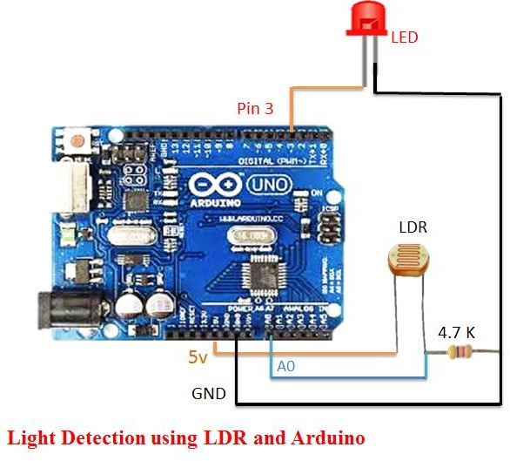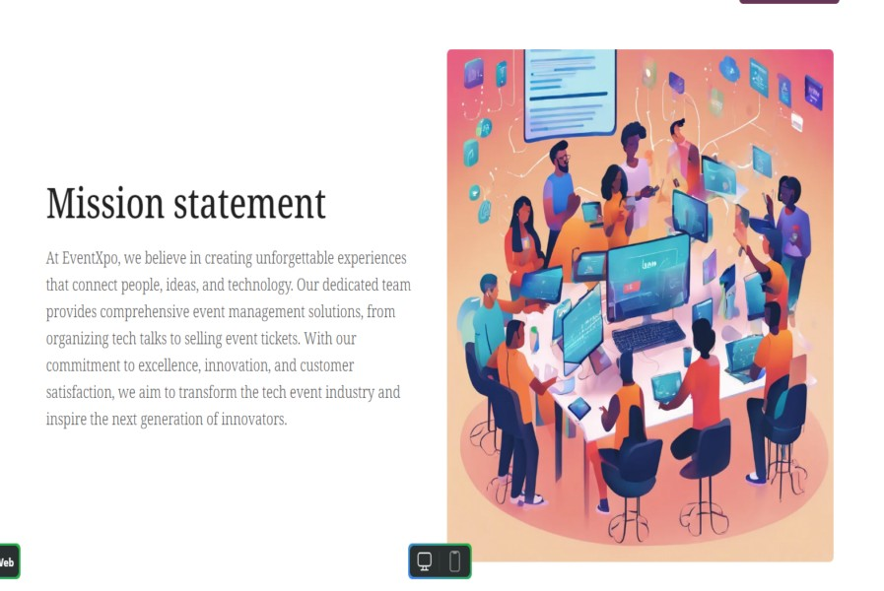



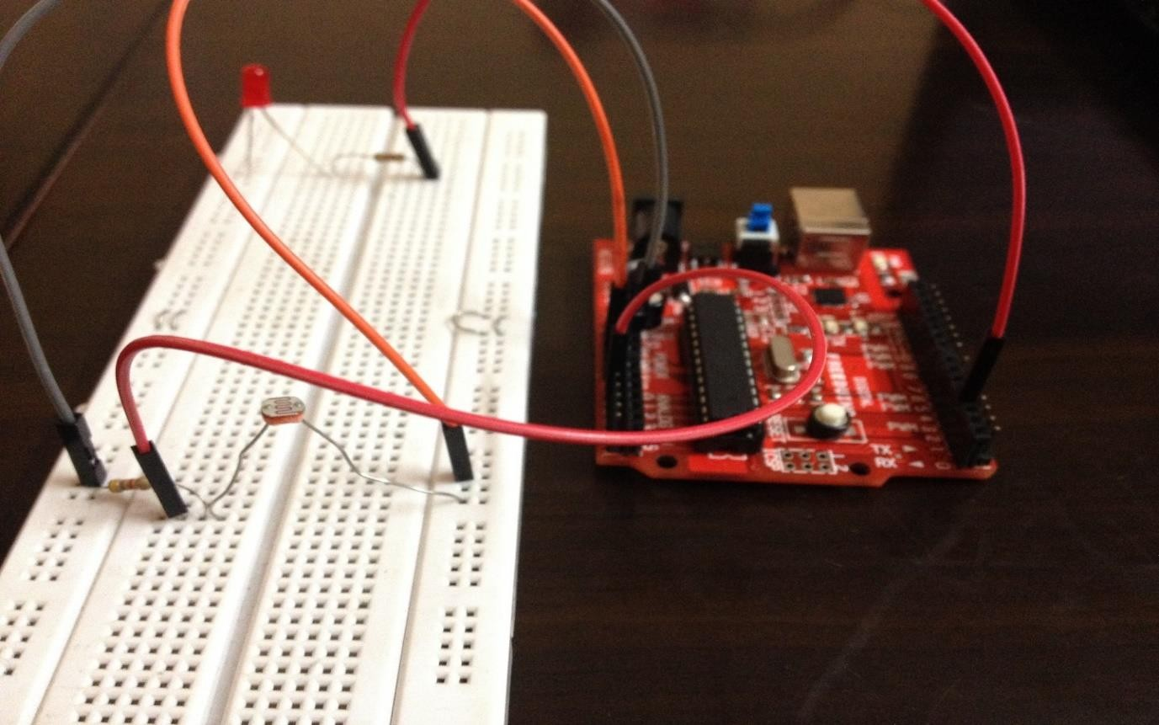

**Characteristics of Arduino:**

• The operating voltage is 5V

• The recommended input voltage will range from 7v to 12V

• The input voltage ranges from 6v to 20V

• Digital input/output pins are 14

• Analog i/p pins are 6

• DC Current for each input/output pin is 40 mA

• DC Current for 3.3V Pin is 50 mA

• Flash Memory is 32 KB

• SRAM is 2 KB

• EEPROM is 1 KB

• CLK Speed is 16 MHz

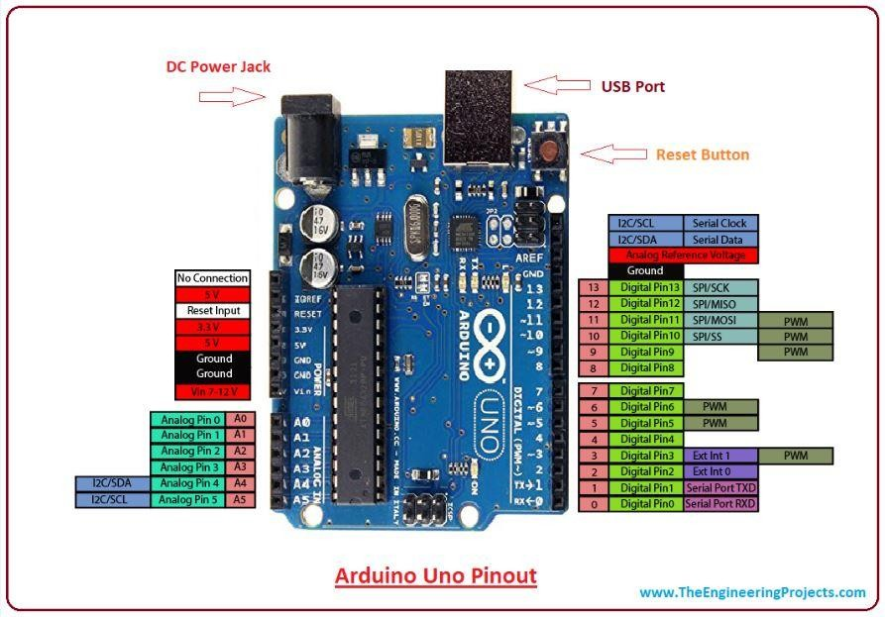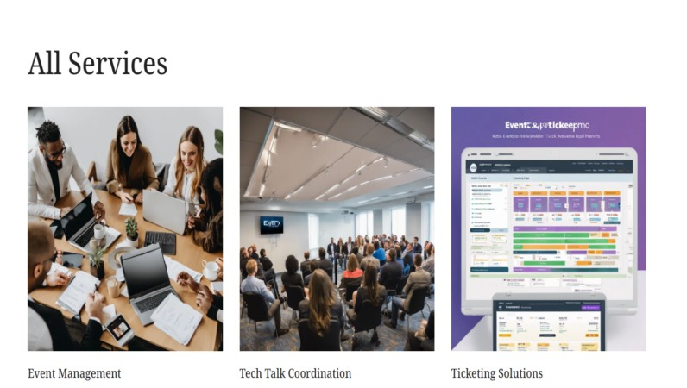

**// source code:**

**CARACTERISTICS OF ‘LDR’:**

LDR’s are light dependent devices whose resistance is decreased when light falls on them and that is increased in the dark. When a light dependent resistor is kept in dark, its resistance is very high. This resistance is called as dark resistance. It can be as high as 1012 Ω and if the device is allowed to absorb light its resistance will be decreased drastically. If a constant voltage is applied to it and intensity of light is increased the current starts increasing. Figure below

shows resistance vs. illumination curve for a particular LDR.

Tech Event Registration Register for Our Tech Event

Full Name:

Email:

Select Event:

Hackathon Tech Talk Workshop

document.getElementById("registrationForm").addEventListener("submit", function(event) {

event.preventDefault();

let formData = new FormData(this); let registrationData = {}; formData.forEach((value, key) => {

registrationData[key] = value;

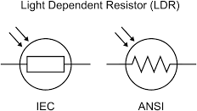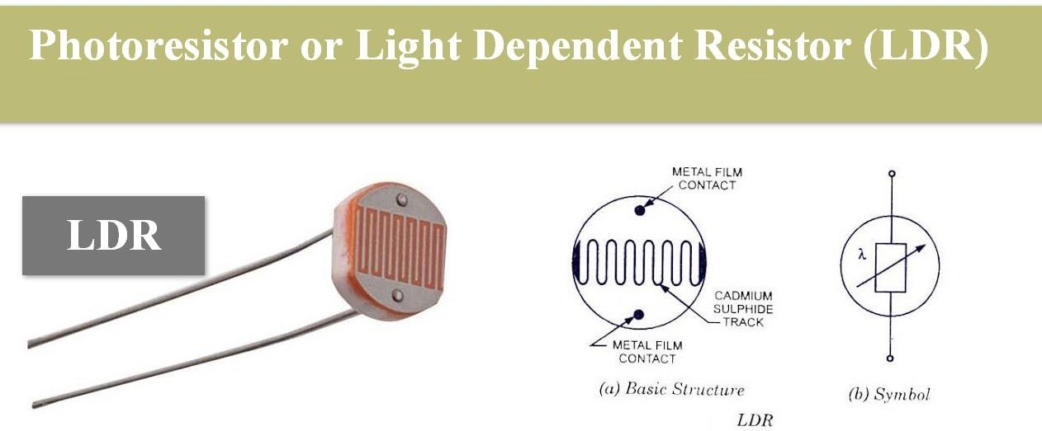

});

});

// Here you can perform further actions like sending data to a server via AJAX console.log("Registration Data:", registrationData);

**// Program related to LDR and LED interfacing to Arduino**

#include <SoftwareSerial.h>

int sensorPin = A0; // select the input pin for the LDR

int sensorValue = 0; // variable to store the value coming from the sensor int led = 3;

void setup() { // declare the ledPin as an OUTPUT: pinMode(led, OUTPUT);

Serial.begin(9600); } void loop()

{

Serial.println("Welcome to TechPonder LDR Tutorial"); sensorValue = analogRead(sensorPin); Serial.println(sensorValue);

if (sensorValue < 100)

{

Serial.println("LED light on"); digitalWrite(led,HIGH); delay(1000);

}

digitalWrite(led,LOW); delay(sensorValue); }



# Literature survey (brief summary of research paper studied)

A literature survey typically involves reviewing and summarizing existing research papers, articles, and scholarly publications relevant to a specific topic or research question. Here's a brief summary of what such a literature survey might look like for a topic related to tech event planning and management:

Automatic street light controller using light dependent resistor (LDR) removes manual works. The street lights are automatically switched ON when the sunlight goes below the visible region of our eyes. It automatically switches OFF the street lights under illumination by sunlight. The component used for light sensing is a Light Dependent Resistor. By using the LDR we can operate the streetlight automatically, when ample amount of light is available the streetlight will be in the OFF state and when it is dark the light will be in ON state, it means LDR resistance is inversely proportional to light falling on it. It exploits the working of a transistor in saturation region and cut-off region to switch ON and switch OFF the lights at appropriate time with the help of an electromagnetically operated switch.

Here two kinds of sensors will be used which are light sensor and photoelectric sensor. The light sensor will detect darkness to activate the ON/OFF switch, so the streetlights will be ready to turn on and the photoelectric sensor will detect movement to activate the streetlights. LDR, which varies according to the amount of light falling on its surface, this gives an induction for whether it is a day-night time, the photoelectric sensors are placed on the side of the road, which can be controlled by microcontroller PIC16f877A. If any object crosses the photoelectric beam, a particular light will be automatically ON. By using this as a basic principle, the intelligent system has been designed for the perfect usage of streetlights in any place.

The project represents a new cost-effective solution for street light control systems. The control system consists of control circuitry, internet and electrical devices. The system also includes the client-server mechanism where a user can directly interact with the web-based application to monitor the Streetlight of any place from a single position. The base server will run a Java Web Application which will maintain whole street light of Country/State/City. Street light controller will receive that information, and it will decode and find the particular streetlight which will set using relay circuit, the notification came it will then decode and finds the appropriate streetlight which needs to put

ON/OFF using relay circuit.

* 1. **Overview of Tech Event Landscape**: The survey would start with an overview of the current landscape of tech events, including trends, types of events (hackathons, tech talks, workshops), and their significance in the tech community.
  2. **Event Planning and Management Techniques**: It would then delve into research on event planning and management techniques, including best practices, strategies for effective event organization, and tools used by event planners.
  3. **User Experience in Event Registration**: The literature survey might explore studies on user experience (UX) in event registration processes, focusing on factors influencing user satisfaction and engagement during the registration process.
  4. **Impact of Technology on Event Management**: Research examining the role of technology in enhancing event management processes would be discussed, including the use of event management software, mobile apps, and other digital tools.
  5. **Social Media and Event Promotion**: Studies investigating the use of social media platforms for event promotion and attendee engagement would be included, highlighting effective social media strategies for reaching target audiences.
  6. **Data Analytics in Event Optimization**: The survey would cover research on data analytics and its application in optimizing event planning and management, including methods for analyzing event data to improve attendee experiences and event outcomes.
  7. **Sponsorship and Revenue Generation**: It would explore research on sponsorship strategies for tech events, revenue generation models, and the impact of sponsorship on event success and sustainability.
  8. **Challenges and Opportunities**: Finally, the literature survey would discuss common challenges faced by event planners and opportunities for innovation and improvement in tech event planning and management practices.

Overall, a literature survey in this domain would provide a comprehensive overview of existing research and insights into key factors influencing the planning, management, and success of tech events.



Sure, here's an overview of the advantages and disadvantages of tech event planning and management:

**ADVANTAGES & DISADVANTAGES:**

By using this automatic system for street light controlling ,we can reduce energy consumption because the manually operated street lights are not switch off properly even the sun light comes and Also not switched on earlier before sunset

• Low cost

• Automated operation

• Low power consumption

• Very flexible

• Easy to manufactured In sunny and rainy days, on and off time differ notice which is one of the major disadvantages of using timer circuit or manual operation for switching the street light system.

**APPLICATIONS:**

Lighting switch The most obvious application for an LDR is to automatically turn on a light at a certain light level. An example of this could be a street light or a garden light.

• Camera shutter control LDRs can be used to control the shutter speed on a camera. The LDR would be used to measure the light intensity which then adjusts the camera shutter speed to the appropriate level.

• Used in street light applications.

• Used in Domestic applications.

**\*\*Advantages:\*\***

1. **Networking Opportunities:** Tech events provide excellent networking opportunities for participants to connect with industry professionals, potential collaborators, and like-minded individuals.
2. **Knowledge Sharing:** Events such as tech talks, workshops, and hackathons facilitate the exchange of knowledge, ideas, and expertise among participants, fostering learning and professional development.
3. **Community Building:** Tech events contribute to the development and growth of vibrant tech communities by bringing together enthusiasts, professionals, and experts to share experiences and build relationships.
4. **Innovation:** Events often serve as platforms for showcasing and exploring cutting-edge technologies, innovations, and emerging trends in the tech industry.

*Disadvantages:**

1. **Cost:** Organizing and attending tech events can be expensive, especially for smaller organizations or individuals, considering registration fees, travel expenses, and other associated costs.
2. **Logistics:** Managing logistics such as venue booking, event promotion, catering, and equipment setup can be challenging and time-consuming for event organizers.
3. **Competition:** The proliferation of tech events can lead to saturation and increased competition for attendees, making it harder for organizers to attract participants and sponsors.
4. **Attendance Fluctuations:** Attendance at tech events can vary significantly depending on factors such as location, timing, competing events, and the quality of speakers or content.
5. **Content Quality:** Ensuring high-quality content and engaging sessions can be a challenge for event organizers, as it requires careful planning, coordination, and selection of speakers and topics.
6. **Technical Challenges:** Tech-related events may encounter technical challenges such as internet connectivity issues, equipment failures, or software glitches, which can disrupt the event experience for participants.

Despite these challenges, the benefits of tech event planning and management often outweigh the drawbacks, contributing to the growth and innovation of the tech industry and community.

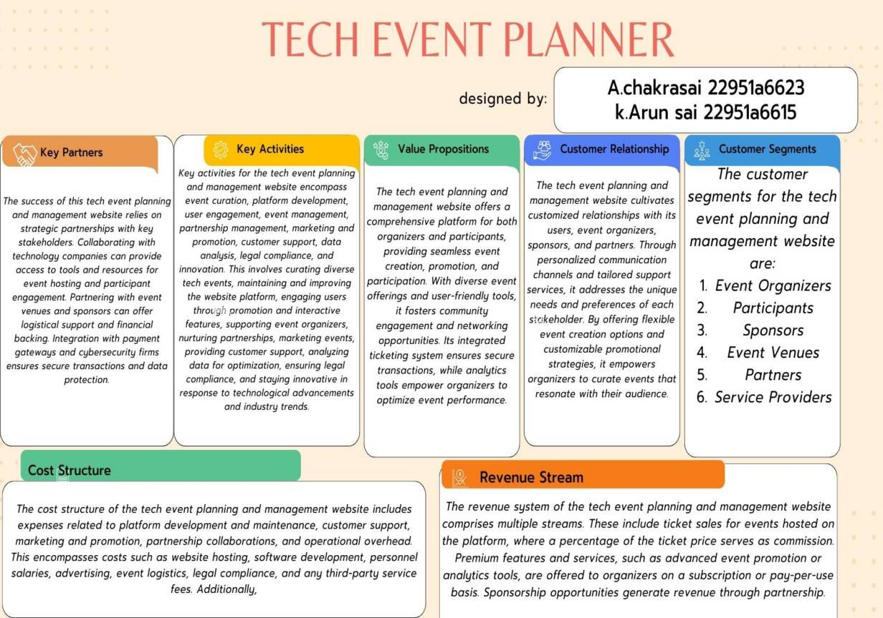

P.KALYANI

H.MANJU BHASHINI

CH.PAVANI



# CONCLUSION:

In conclusion, tech event planning and management play a vital role in fostering collaboration, innovation, and community engagement within the technology industry. Despite facing challenges such as cost, logistics, and competition, the advantages of tech events—including networking opportunities, knowledge sharing, and professional growth—significantly outweigh the disadvantages. By providing platforms for learning, networking, and showcasing innovations, tech events contribute to the development of vibrant tech communities and the advancement of the industry as a whole. Moreover, the increasing accessibility of virtual and hybrid event formats has opened up new possibilities for reaching broader audiences and overcoming geographical barriers. As technology continues to evolve, so too will the landscape of tech events, presenting opportunities for organizers to innovate and adapt to changing needs and preferences. Ultimately, tech event planning and management remain essential components of the tech ecosystem, facilitating connections, driving innovation, and shaping the future of technology.

More effective in case of cost, manpower and security as compare with today's running complicated and complex light controlling systems. Automatic Street Light Controlling System puts up a very user friendly approach and could increase the power This The Streetlight controller using ldr based Light intensity & traffic density, in the todays up growing countries will be paper elaborates the design and construction of automatic street control system circuit. Circuit works properly to turn street lamp ON/OFF.

After designing the circuit which controls the light of the street as illustrated in the previous sections. LDR sensor and the photoelectric sensors are the two main conditions in working the circuit. If the two conditions have been satisfied the circuit will do the desired work according to specific program.

The street lights has been successfully controlled by microcontroller. With commands from the controller the lights will be ON in the places of the movement when it's dark. furthermore the drawback of the street light system using timer controller has been overcome, where the system depends on photoelectric sensor.

**Future scope:**

In the future, we can expect to see solar street lights integrated with other smart city systems such as traffic lights, waste management systems, and public safety systems. This integration will improve the efficiency and effectiveness of these systems while reducing energy consumption.

FUTURE SCOPE The above project we can develop solar street light system with Automatic street light controller. The system can be powered from a battery, which can be charged during day time by harvesting the solar energy through a solar cell.

**Signature of the faculty**

## Future scope:

The future scope of tech event planning and management is bright, with several promising trends on the horizon. These include the continuation of hybrid events, combining in-person and virtual components for increased accessibility. Advancements in virtual event technology will enhance virtual experiences, offering interactive features and immersive environments. Personalization through data analytics and AI will tailor event recommendations and content to attendees' preferences. Sustainability will become a priority, with organizers implementing eco-friendly practices. Emerging technologies like AI, blockchain, AR, and VR will feature prominently, showcasing their applications across industries. Niche and industry-specific events will cater to specialized interests, while partnerships between organizers and stakeholders will create new opportunities for collaboration and growth.

Signature of the faculty

## Signature of the faculty